**Pie Checker Website**

**Introduction:**

The Pie Checker website was created solely for the use of the product. This is how the user will be able to view their food that is baking in their kitchen. The product allows the user to remotely view their food via live streaming video, save images to their gallery and view other user’s shared images. It was created using a combination of HTML, CSS, and Javascript. The design guidelines were made using Photoshop. The frame work, such as the buttons and text, were created using HTML and completed with placement and colors using CSS. The functions were added using Javascript

**Initial Design Features:**

This website contains five different pages in which the user can navigate through via a sidebar menu. Each page link is represented on the menu bar along with an option to logout of the account.

**Login page:** This page is where the user must either login to or register to Piechecker. After registering the user will receive a confirmation email for their account.

**Home page:** The homepage is where the user can see pictures shared by other users and see a description about the product.

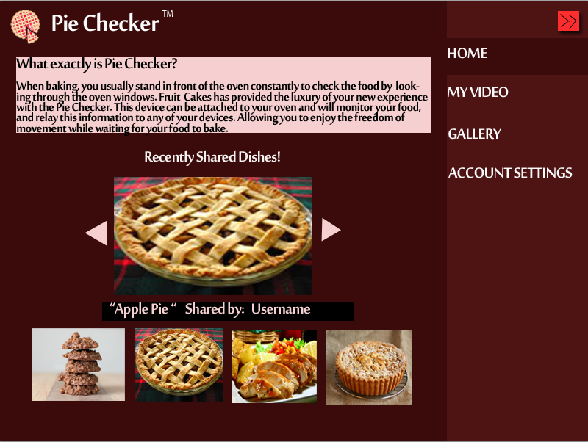

**My Video page:** The my video page is where the user will be able to view their live streaming video. They will be able to pause or stop the video as they desire and have the option to change the view to full screen. Also the user can select which device they wish to see if they have more than one pie registered to their account. On this page, the current cooking temperature and time are displayed for the users convenience.

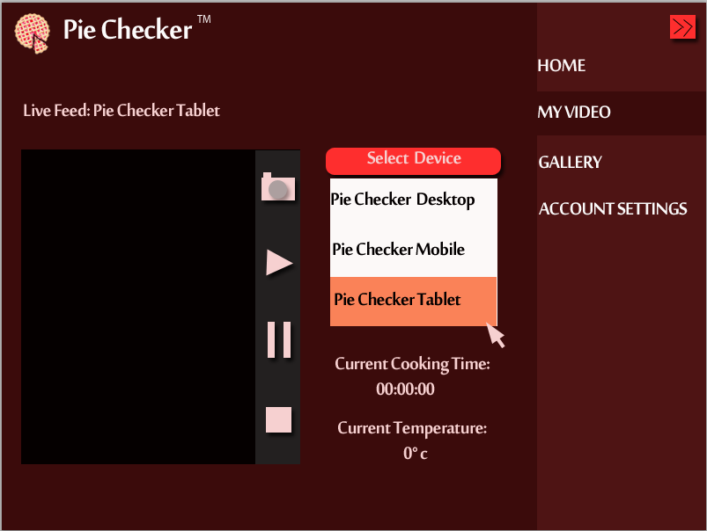

**Gallery page:** The gallery page is where the user will be able to review their previously stored recordings and thumbnails of the dishes. By simply clicking on an image, the user will be able to view it in a larger form.

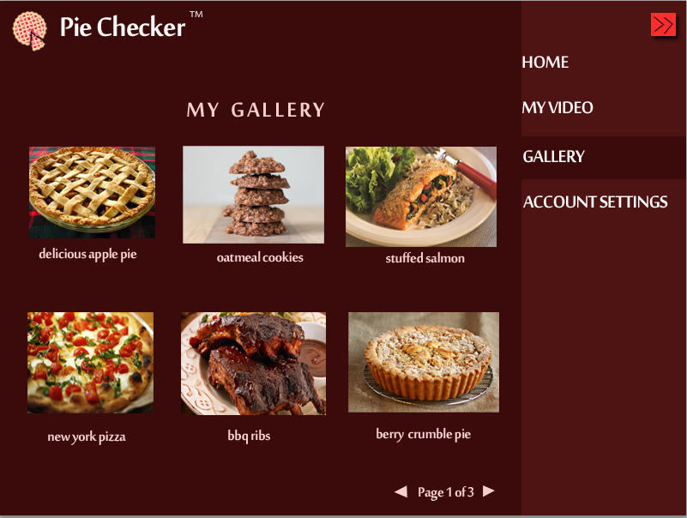

**Account Settings page:** The account settings page is where the user will have the option to add or remove Piecheckers from their account, change their password, or even deactivate their account completely.

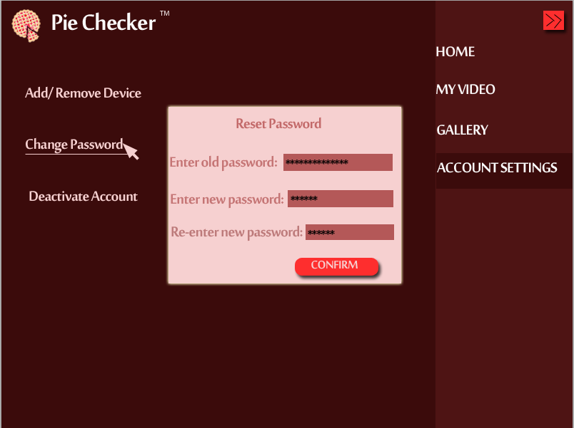

**Finished Design Features:**

**Initial Login/Register page:** when the user goes to our Piechecker website (<http://piechecker.com>) they will have an option to register via TwitchTV. Our project’s login system will use a TwitchTV account in order to stream and save live videos. after logging in, the user will be redirected to the Piechecker homepage to continue on with using our product.

**Home Page?:**

**Setup Page?:** first page you see when logging in

**About Us Page?:** logged out

**Streamer Page?:** canwatch other user’s streams

**Conclusion:**

The initial design has many differences compared to the actual product. When developing the website, we faced several challenges to make the pages exactly how we would have liked to have them. One huge aspect of the website that changed was our login system. We realized that if we use our own server and database, the users’ video streaming would accumulate a very hefty cost for us in which we are not willing to pay. Instead of using our own server, we are piggy backing off of a program called “TwitchTV”. by logging into your TwitchTV account, the user will manually redirect the page back to Piechecker.com and our website will recieve all the users information from TwitchTV. By changing our backend system so drastically, we didn’t have enough time to complete our website following the initial design. After all the changes were made, the website looks different but the requirements for functions are still met. It would have been easier to continue using what we had except the login system would not have functioned properly.

Because we are using TwitchTV more or less as our “back-end”, we can use the SD card for the pie as our database. We store the code and everything the user needs in order for the piechecker to work on the card and the user can download the info from our website. This help us to have a nice and easy installation process.